**Pre lab 7**

This is a plan for writing the code:

1. **Construct the Vandermonde matrix:** Write a function that takes the interpolation points ( x0, x1, ..., xn ) and constructs the Vandermonde matrix.

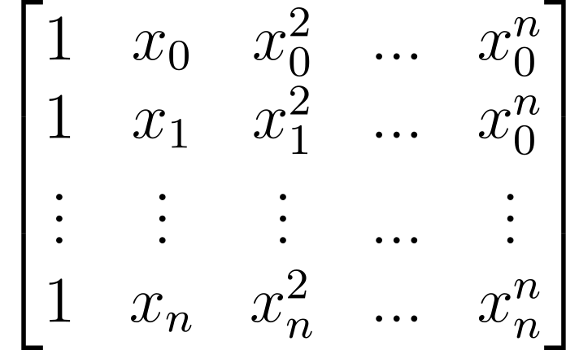

1. **Solve the linear system:** Write a function that takes the Vandermonde matrix and the function values ( f(x0), f(x1), ..., f(xn) ) and solves the linear system to find the coefficients ( a0, a1, ..., an) by using *np.linalg.solve*

1. **Evaluate the polynomial:** Once you have the coefficients, write a function that takes the coefficients and an input value (x) and evaluates the polynomial (pn(x)) using the coefficients.